Karnataka Valuation & E-Registration (KAVERI - 2.0)
Government of Karnataka

Functional Requirement Specifications

For KAVERI 2.0
Department of Stamps & Registration
Government of Karnataka

Book 1- Part III(b)
Land Acquisition

Prepared by
Centre for Smart Governance (CSG)
2nd Floor, TTMC Yeshwanthapura, BMTC Bus station
Bangalore – 560022

Contents
Book-1 Part III(b): Land Acquisition statement 4
Overview 4
Overall functional flow 4
Functional requirement Description 4
Workflow 5
Actors and their roles 6
Wireframes 8
Input and Output Validations 8
Integration with other systems/modules 8
a. External integration 8
b. Internal integration with other modules 8
Assumptions and Dependencies 10
Assumptions: 10
Dependencies: 10
Annexures 10
Annexure – 1 – List of modules of Kaveri 2.0 10
Annexure- 2 – Requirements as shared by the department 11
Annexure – 3 Endorsement 11
Annexure – 4 Index II(EC) 12

Acronyms
BDA | Bangalore Development Authority
DEO | Data Entry Operator
FDA | First Division Assistant
KIADB | Karnataka Industrial Area Development Board
K2 SRO | Kaveri 2 Sub-registrar Office
MUDA | Mysore Urban Development Authority
SDA | Second Division Assistant
TUDA | Tumkur Urban Development Authority

Revision History
Version | Date | Description / Modifications | Prepared by / Modified by
1.0 | 13/08/2024 | First Version | Arugolli Subhash
1.1 | 21/09/2024 | Changes suggested by the Department, and the addition of scanning and uploading the certificate. | Pavan Kumar Deshapande

Book-1 Part III(b): Land Acquisition statement

Overview
To urbanize, authorities such as BDA, MUDA, TUDA, KIADB, etc., will acquire revenue land under the Land Acquisition Act 1894. The Relevant authorities will send a copy of the statement to the jurisdictional registering officer, who will file it and make an entry in Book No-1, electronically for storing and preserving it.
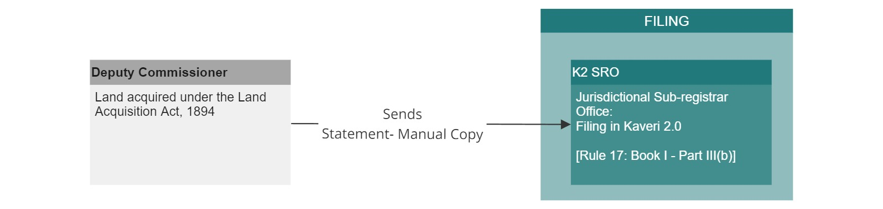
Figure 1: Process of Land Acquisition

Overall functional flow
The below-mentioned functionalities take place in the office of the Sub Registrar under the Department of Stamps and Registration of Government of Karnataka under the Karnataka Registration Rules, 1965. Filing module functionalities of Kaveri 2.0 are elaborated in this document.

Functional requirement Description
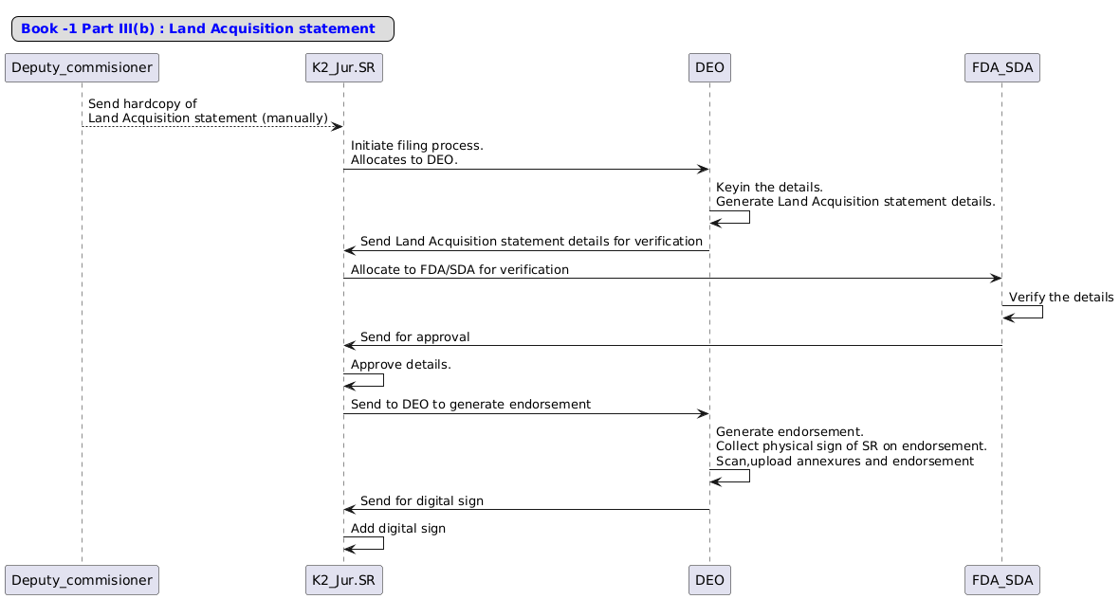
Figure 2: Interaction diagram of Land Acquisition

Workflow
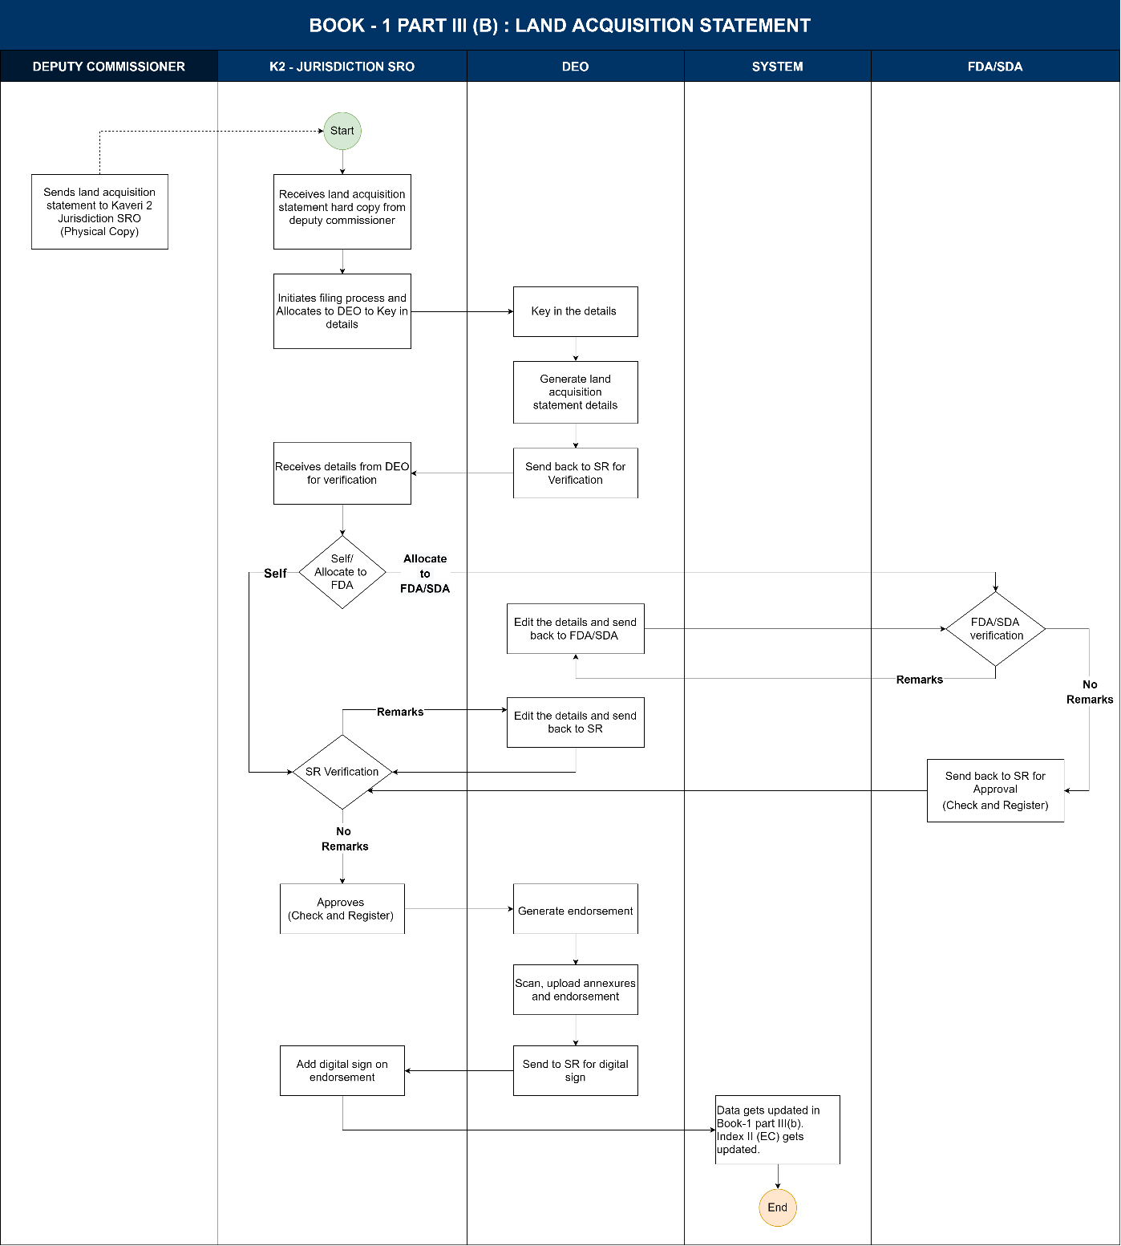

Actors and their roles
Functional Requirement Specifications
Stakeholder/ Interface | Role/ Responsibilities
Deputy Commissioner | Send a manual copy of the Land acquisition order to the Kaveri 2.0 Sub-registrar office
SRO | - Receives a manual copy of the Land acquisition order from the Relevant Authorities.  - Initiate the filing process.  - Allocates to DEO to key in the details.  - Provide a manual copy of the Land acquisition order to DEO to key in details.  - Allocates details to FDA for verification.  - Self-verify the details.  - Approves details by check and Register.  - Signs physically and digitally on the Endorsement.
DEO | - Enters all the details mentioned in the Land acquisition notification.  - Generates the report.  - Sends details report to SR for verification.  - Scan, and upload the land acquisition statement.  - Takes physical signature on Endorsement.  - Sends endorsement to SR for Digital sign.
FDA/SDA | - Verifies the details generated by DEO.  - Add remarks if required after verification.  - Send back the verified details to SR for further processing.
System | - Based on the details entered, the system should generate a report.  - Once the report is approved by SR, the system should generate endorsements.  - Allow DEO to scan and upload the land acquisition statement.  - Allow SR to digitally sign the Endorsement.  - Store this data and reflect in Book 1 Part III(b).  - Updates Index II (EC).  - Generates filing number with date.
Output documents generated | Endorsement,  contains:  - Section 60 Certificate: Book -I part III(b).  - Filing Number with Date.
Internal changes | Book-1 Part III(b).
Impact on other modules | - EC Search.  - MIS.

Process Description
The Relevant Authorities will send the Land acquisition order to the concerned jurisdictional SRO (manually) for filing.
Filing process
K2 jurisdictional SRO initiates the process by entering the Issuing authority, Date of Issue and notification number and allocates the task of inputting details from the Land acquisition statement to DEO.

DEO - Data entry
- DEO inputs details according to the Land acquisition statement:
  - Property details.
  - Boundary details.
  - Schedule Description.
  - Party details.
- DEO repeats the above step until he adds all the properties mentioned in the land acquisition order and once he finishes then proceeds to the next step.
- DEO generates the report and sends it back to SR for approval.
- SR can either self-verify or allocate to the FDA for Verification.

SR - FDA/ SDA allocation
- SR selects the FDA/SDA from the drop-down and clicks on the allocate button.
- FDA/SDA receives the report in the dashboard for verification.

SR - Self Verification
- SR clicks on ‘Verify’ button to verify the report.
- SR adds remarks if any and sends it back to DEO for editing/correcting.
- If there are no correction SR approves for registration.

DEO - Correction
DEO views the remarks given by SR/FDA/SDA, updates them and sends the modified report to them.

FDA/SDA - Verification
- FDA/SDA receives the report with corrections in the dashboard for verification from DEO.
- FDA/SDA verifies the report and sends it back to SR for approval.

SR - Approval
- SR receives the report after modification in the dashboard for verification from DEO.
- SR receives the report for approval from the FDA/SDA.
- SR approves the report Summary and Check and Register.
- Once SR registers, DEO generate endorsement, prints it and will take a printout of endorsement.
- DEO takes the physical signature of the SR on the endorsement, uploads physically signed endorsement, annexures and sends them to SR for Digital sign.

SR – Digital Sign
- SR signs on the hard copy of the Endorsement and had it over to DEO to scan and upload endorsement and Annexures.
- Once the SR receives the application in dashboard to digitally sign the document.
- SR adds digital sign on endorsement and all the pages uploaded with it.

System activities
- Updates MIS: Book-1 Part III(b)
- Updates index II (EC)

Wireframes
https://www.figma.com/proto/l5qKp1Z62SIwAzQmxut7QB/Kaveri-2.0?page-id=2337%3A2276&node-id=3127-6294&viewport=1728%2C948%2C0.05&t=AuvJdW9ZjfKnl53C-1&scaling=scale-down-width&content-scaling=fixed&starting-point-node-id=3127%3A6294&show-proto-sidebar=1

Input and Output Validations
Input validations
- A minimum of 1 executant and 1 claimant are required, without which DEO cannot proceed further.
- At least 1 property detail should be entered to continue with the application.
- All text fields will have a maximum of 250-character limits.
- Description field is an alphanumeric field which should have 1000 characters limit including all the special characters.
- Without entering the mandatory fields application should not proceed further.
Workflow validations
- SRO should be able to select and allocate to DEO.
- In case of DEO’s absence or FDA’s absence, the system should have the provision of a suggested in-charge.
- System provides a unique Filing number to the submitted application.
- All entries in each book shall be numbered in a consecutive series, which shall commence and terminate with the year, a fresh series being commenced at the beginning of each year.

Integration with other systems/modules

External integration
- No Integration 1.

Internal integration with other modules
- MIS.
- EC.

Implications for MIS:
After the document is filed and entry made in Book 1 Part III(b), the MIS Report (in Statutory reports) has to be generated:
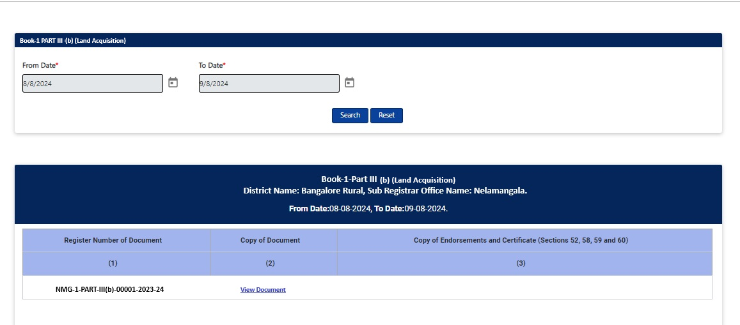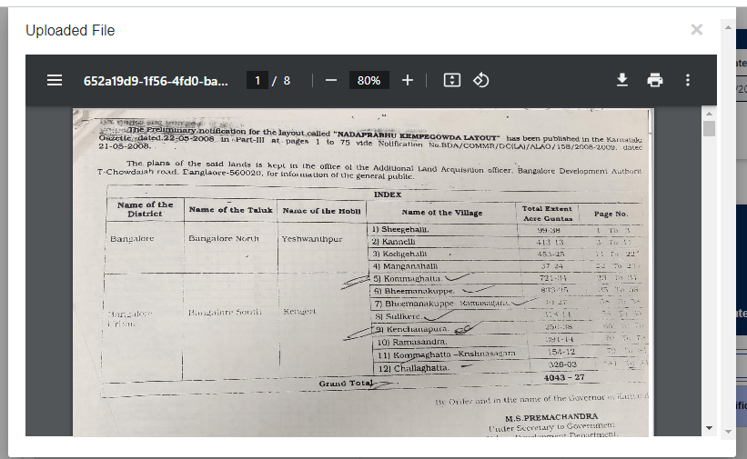
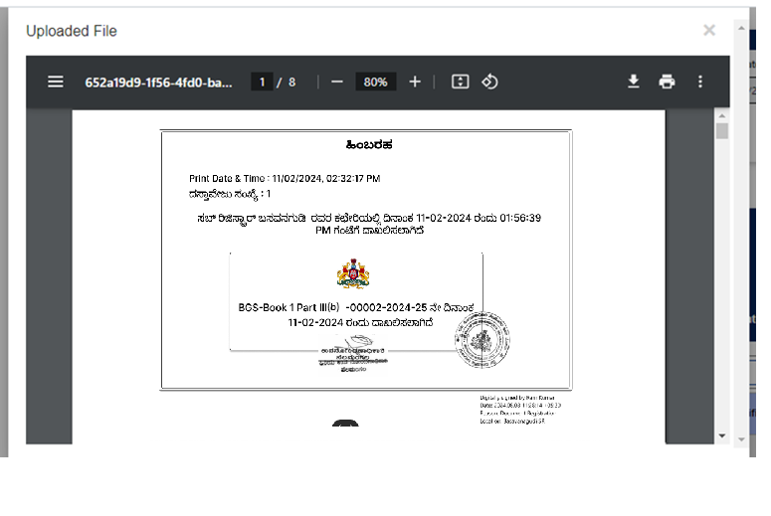

Assumptions and Dependencies

Assumptions:
- The Relevant Authorities send a copy of the Land acquisition order/ statement manually.
- K2 SRO sends the acknowledgement to the Relevant Authorities after the filing process (if required).
- All the properties listed in the land acquisition order will get a distinct filing number.
- No fees are calculated or collected including scanning fees.
- No J-slips will be sent.

Dependencies:
- No Dependencies.

Annexures

Annexure – 1 – List of modules of Kaveri 2.0
Sl No | Module No | Main Module | Sub-Module
1 | 1.1 | Registration | Registration
2 | 1.2 | Registration | Appointment
3 | 1.3 | Registration | Integration module
4 | 1.4 | Registration | Stamp duty and Registration fee calculation
5 | 1.5 | Registration | Guideline value calculation
6 | 1.6 | Registration | Rule 17 (2) filing
7 | 1.7 | Registration | Rule 17 (3) filing
8 | 1.8 | Registration | Old pending release module
9 | 1.9 | Registration | Re-Registration module
10 | 1.1 | Registration | Will after Death
11 | 1.11 | Registration | Filing documents (FRUITS)
12 | 1.12 | Registration | Scanning
13 | 1.13 | Registration | Memo transmission and filing
14 | 1.14 | Registration | 68(2) correction
15 | 1.15 | Registration | Cross-reference Rule 123
16 | 1.16 | Registration | Integration exemption
17 | 1.17 | Registration | Court entry
18 | 1.18 | Registration | Liability
19 | 1.19 | Registration | Status tracking
20 | 1.2 | Registration | Investigation and Search
21 | 1.21 | Registration | Valuation Module (CVC)
22 | 2 | EC
23 | 3 | CC
24 | 4 | Verify Document
25 | 5 | Power of attorney Authentication Module
26 | 6 | Refund Module
27 | 7.1 | Marriage | Hindu Marriage
28 | 7.2 | Marriage | Special Marriage
29 | 7.3 | Marriage | Special Marriage in Other Forms
30 | 8 | Legacy Record digitisation
31 | 9 | Audit
32 | 10 | Accounts
33 | 11.1 | MIS | Statutory (44)
34 | 11.2 | MIS | Statistical (54)
35 | 11.3 | MIS | Integration (15)
36 | 11.4 | MIS | Computer related (4)
37 | 11.5 | MIS | Reconciliation (5)
38 | 11.6 | MIS | HR (5)
39 | 12.1 | DRO | Firm Registration
40 | 12.2 | DRO | Undervaluation
41 | 12.3 | DRO | Deposit of will
42 | 12.4 | DRO | Adjudication of documents
43 | 13 | IGRO | Appeal
44 | 14 | Master Data Management
45 | 15 | User Management
46 | 16 | Mobile application
47 | 17 | Training Module | Master Trainer, Training Plan

Annexure- 2 – Requirements as shared by the department
Requirements were shared verbally and workflows were verbally approved in August 2023

Annexure – 3 Endorsement
The final Endorsement contains the below-mentioned details:
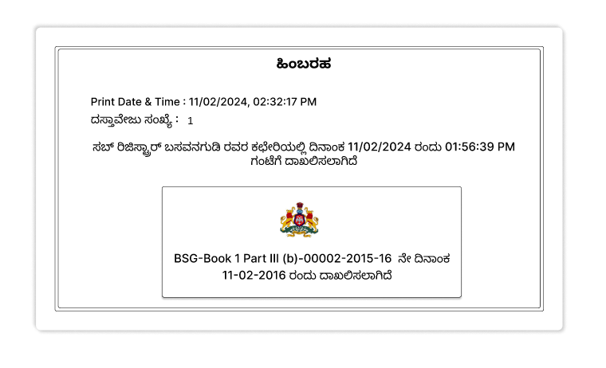

Annexure – 4 Index II(EC)
